



Administrative Support Team
(255)

STATE 2024

PRODUCTION
Job 1: Logo __________ (60 points)
Job 2: Brochure __________ (200 points)
Job 3: Table w/borders __________ (125 points)
Job 4: News Release __________ (100 points)
Job 5: Database Report __________ (110 points)
Job 6: Speech __________ (100 points)
TOTAL POINTS __________ (695 points)

Test Time: 90 minutes

GENERAL GUIDELINES:
Failure to adhere to any of the following rules will result in disqualification:
- Member must hand in this test booklet and all printouts if any.
- No equipment, supplies, or materials other than those specified for this event are allowed in the testing area. No previous BPA tests and/or sample tests (handwritten, photocopied, or keyed) are allowed in the testing area.
- Electronic devices will be monitored according to ACT standards.

EXAM GUIDELINES:
- Ensure this test booklet contains Jobs 1-6.
- Key all jobs according to the instructions given.
- Correct any and all formatting, spelling, or grammar errors. Use the formatting guide in the Style & Reference Manual.
- Your name or initials should not appear on any work you submit. Use your Member ID in any occasion you would normally key your reference initials.
- In the lower right hand corner of ALL work submitted (unless otherwise specified), key your Member ID and job number.
- If you complete the event before the end of the time allotted, notify the proctor. Time may be considered a factor in determining a winner when there is a tie score.
- Place your scoring sheet on top of your jobs. Jobs should be placed in numerical order.

PRODUCTION STANDARDS
0 Errors | 100 Points
1 Error | 90 Points
2 Errors | 70 Points
3 Errors | 50 Points
4+ Errors | 0 Points

JOB | CRITERIA | POINTS POSSIBLE | POINTS
Job 1  Logo Creation  60 points | Only Used Graphics Provided | 10 points
Job 1  Logo Creation  60 points | Integrated Tagline | 10 points
Job 1  Logo Creation  60 points | Design/Creativity | 40 points
Job 1  Logo Creation  60 points |  | Total | /60
Job 2  Brochure  200 points | Production Standards | 0 errors = 100 points  1 error = 90 points  2 errors = 70 points  3 errors = 50 points  4+ errors = 0 points
Job 2  Brochure  200 points | Logo Job 1 Incorporated | 10 points
Job 2  Brochure  200 points | 3-column brochure, front/back, no templates | 20 points
Job 2  Brochure  200 points | Design/Creativity | 70 points
Job 2  Brochure  200 points |  | Total | /200
Job 3  Table with Borders  125 points | Production Standards | 0 errors = 50 points  1 error = 45 points  2 errors = 40 points  3 errors = 35 points  4+ errors = 0 points
Job 3  Table with Borders  125 points | Our Cost, Price numbers 2 decimals | 5 points
Job 3  Table with Borders  125 points | Profit Column calculated w/formula | 20 points
Job 3  Table with Borders  125 points | Profit Column numbers 2 decimals | 5 points
Job 3  Table with Borders  125 points | Average row added & calculated w/ formula | 20 points
Job 3  Table with Borders  125 points | Sorted by item | 10 points
Job 3  Table with Borders  125 points | Table printed | 5 points
Job 3  Table with Borders  125 points | Printed with formulas | 10 points
Job 3  Table with Borders  125 points |  | Total | /125
Job 4  News Release  100 points | Production Standards | 0 errors = 100 points  1 error = 90 points  2 errors = 70 points  3 errors = 50 points  4+ errors = 0 points
Job 4  News Release  100 points |  | Total | /100
Job 5  Database Report  110 points | Production Standards | 0 errors = 50 points  1 error = 45 points  2 errors = 40 points  3 errors = 35 points  4+ errors = 0 points
Job 5  Database Report  110 points | Group by Category, Sort by Item, Average, Portrait | 20 points
Job 5  Database Report  110 points | No information truncated | 10 points
Job 5  Database Report  110 points | Summary info removed, AVG to Average & moved | 10 points
Job 5  Database Report  110 points | Bold headings, change header, add subheading, add Job 5-XXXXXXXX in report footer | 20 points
Job 5  Database Report  110 points |  | Total | /110
Job 6  Speech  100 points | Production Standards | 0 errors = 100 points  1 error = 90 points  2 errors = 70 points  3 errors = 50 points  4+ errors = 0 points
Job 6  Speech  100 points |  | Total | /100
Job 6  Speech  100 points |  | Total | /695

PRODUCTION
Job 1: Logo Creation

Note to Grader: Designs will vary. Tagline “We perk you up!” must be included and only graphics provided (see below) can be used.

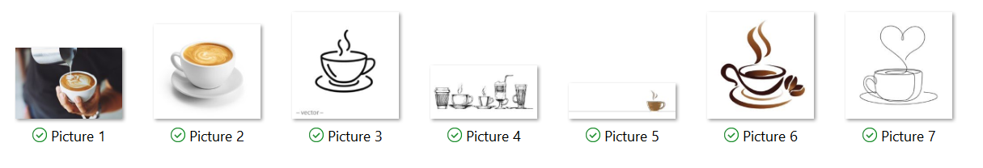
Job 2: Brochure

Teams are to create a 3-column brochure (front and back) for the Grand Opening using the logo created in Job 1 to advertise the new coffee shop. No templates should be used. Teams may use any of the other graphics provided in Job 1.

The following items need to be included:
Grand Opening, May 15-19, 2024
Hours 6 am-4 pm
Location: Main lobby of Digital Solutions (use the address given in the instructions)

Menu:
Drip Coffee $2
Iced Coffee $3
Latte $4.25
Iced Latte $4.25
Cappuccino $4.25
Espresso Shot $2
Iced Macchiato $4.25
Frappe $4
Hot Tea $2
Iced Tea $2
Hot Apple Cider $2
Hot Chocolate $2

Extras:
Whipped Cream $.50
Syrups (French vanilla, caramel, hazelnut, mint, vanilla, salted caramel, white chocolate, pumpkin spice, coconut) $.75

Milk choices:
Whole, skim, almond, coconut, half & half, soy, oat

Sizes
12 oz
16 oz (add $1)
20 oz (add $2)

Enter to win the following prizes during our grand opening:
$50 Gift Card
$25 Gift Card
$15 Gift Card
$10 Gift Card
T-shirts
Hats

Find all of our information on our website www.thegrindcafe.com or follow us on Facebook at The Grind Café at Digital Solutions or on Instagram at the.grind.café. Contact us at The Grind Café at 888-352-9870, email at thegrindcafe.com.
We accept cash, cards (Amex, Visa, Mastercard, Discover), Apple Pay, Google Pay,
Gift cards are available.

Job 3: Table with Borders

THE GRIND CAFÉ

May 2024 Opening Pricing

Item | Our Cost | Price | Profit
Cappuccino | $1.90 | $4.25 | $2.35
Drip Coffee | .75 | 2.00 | 1.25
Espresso Shot | .50 | 2.00 | 1.50
Frappe | 1.90 | 4.00 | 2.10
Hot Apple Cider | 1.25 | 2.00 | 0.75
Hot Chocolate | .25 | 2.00 | 1.75
Hot Tea | .50 | 2.00 | 1.50
Iced Coffee | 1.50 | 3.00 | 1.50
Iced Latte | 1.90 | 4.25 | 2.35
Iced Macchiato | 1.75 | 4.25 | 2.50
Iced Tea | .75 | 2.00 | 1.25
Latte | 1.90 | 4.25 | 2.35
Average | $ 1.24 | $ 3.00 | $ 1.76

XXXXXXXX
Job 3
Printout with formulas

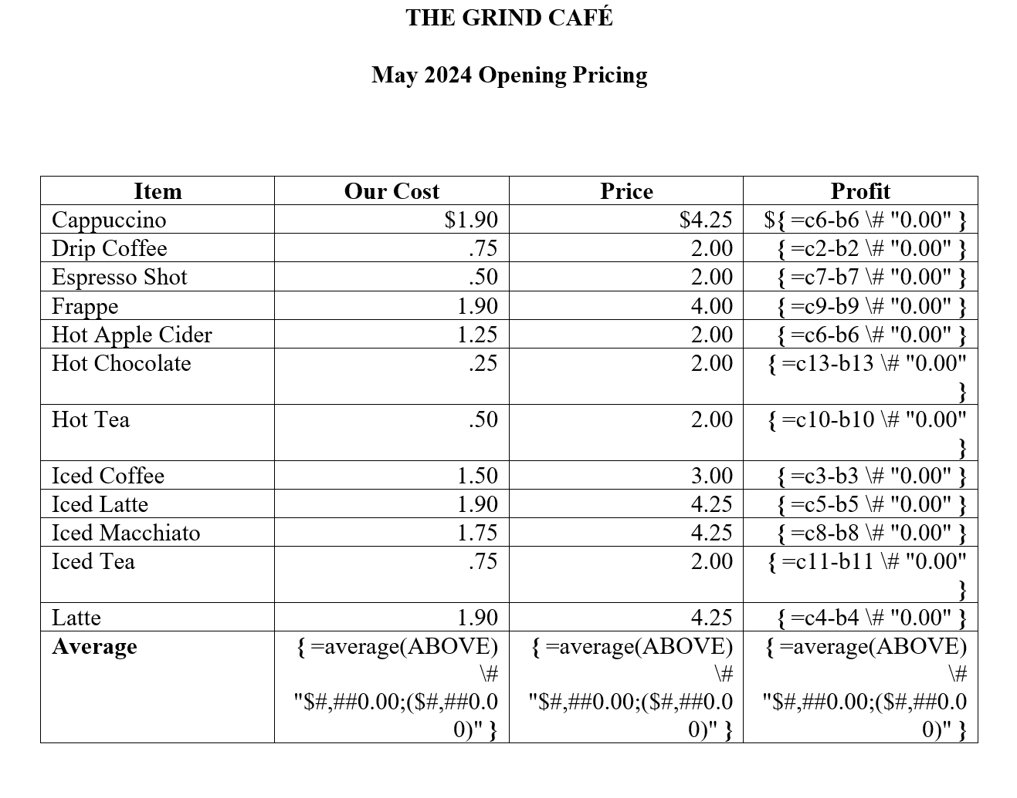
XXXXXXXX
Job 3
Job 4: News Release

NEWS RELEASE
From Roger Meyer
700 Morse Road, Suite 201
Columbus, OH 43214
614-555-5555

Release April 15, 2024

DIGITAL SOLUTIONS NEW COFFEE SHOP

Digital Solutions is so excited to announce that they will be adding a coffee shop to their lobby at their corporate headquarters at 700 Morse Road, Suite 201, Columbus, Ohio. The coffee shop will be called The Grind Café. It will be open from 6 a.m. to 4 p.m. daily and will feature hot and cold beverages including coffee, tea, hot chocolate in a variety of sizes. The grand opening for the shop is slated for May 15-19, 2024. There will be an opportunity to register for prizes during this time period and the public is welcome.
You can find more information about the café on their website www.thegrindcafe.com or follow the café on Facebook at The Grind Café at Digital Solutions, or on Instagram at the.grind.cafe. For more information you can contact the café at 888-352-9870 or email thegrindcafe.com. The café will accept cash, cards (Amex, Visa, Mastercard, Discover), Apple Pay, Google Pay.
# # #

XXXXXXXX
Job 4

Job 5: Database Report

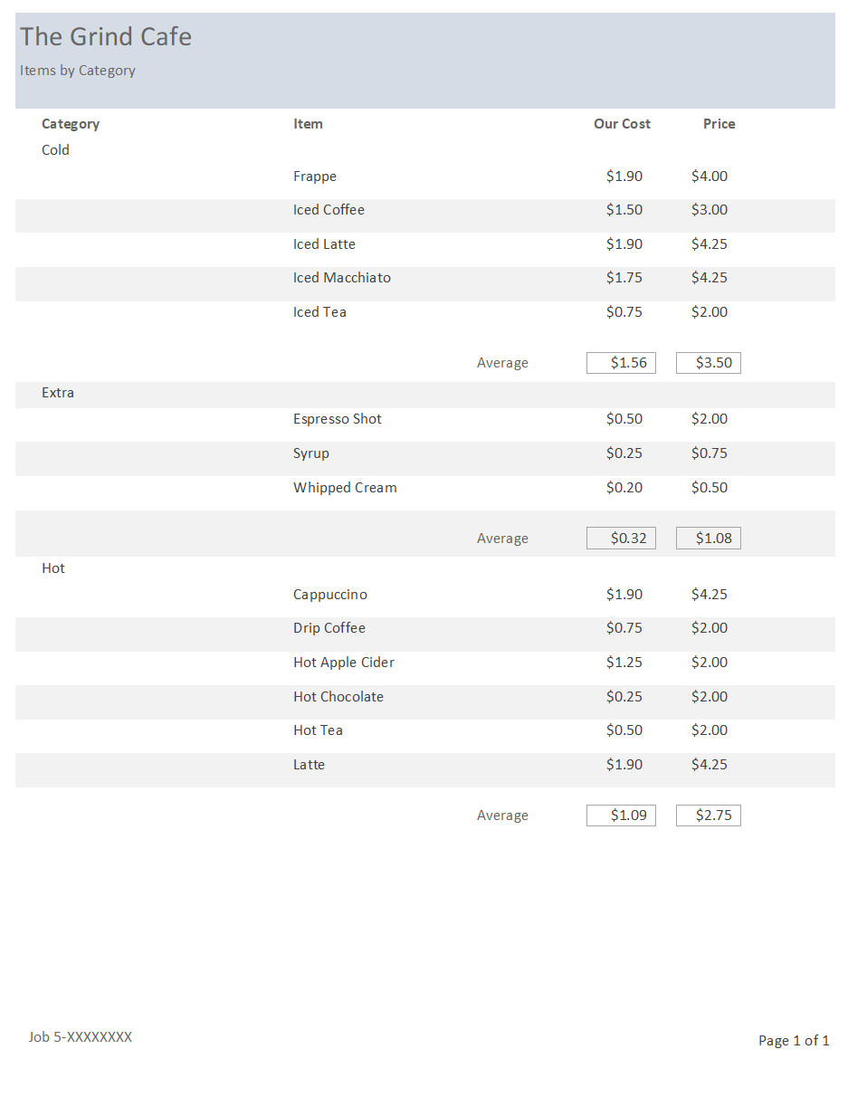

Job 6: Speech
DIGITAL SOLUTIONS NEW CAFÉ

Grand Opening

Digital Solutions is excited to announce the Grand Opening of their newest adventure, The Grind Café. This addition to our business has been in the planning stages for the past two years. All staff will receive a $10 credit in their account each month to use toward purchases. The café will be open from 6 a.m. to 4 p.m. daily, Monday through Friday. Customers can order items online or using the café’s app.
Digital Solutions will be taking suggestions from staff and the public for items to add in the future to expand the menu. Make sure you follow the café on Facebook at The Grind Café at Digital Solutions, on Instagram at the.grind.café, or on the website www.thegrindcafe.com to find out about specials and additions to the menu. Don’t forget to sign up for all the amazing door prizes that are available. Door prizes will be announced on May 20.

